Standard Operating Procedure (SOP)
DHCP Server Configuration – Windows Server
This Standard Operating Procedure (SOP) documents the structured installation and configuration of the DHCP Server role on a Windows Server Domain Controller (DC01). The purpose of this SOP is to demonstrate enterprise-grade DHCP deployment practices, including scope segmentation, address management, lease optimization, and client configuration. All steps align with Pages 10–13 of Jake’s Tech Labs and mirror real-world administrative workflows.

1. Environment Overview
Server Name: DC01
Server Roles: Active Directory Domain Services, DNS, DHCP
Network Type: Internal / Lab Network
Management Tools: Server Manager, DHCP MMC

2. Access Server Manager and Prepare Role Installation
The Server Manager dashboard is accessed on DC01 to initiate role-based configuration. Using Server Manager ensures roles are installed in a controlled, Microsoft-supported manner and allows dependency validation before deployment. This step establishes a centralized management starting point for DHCP services.
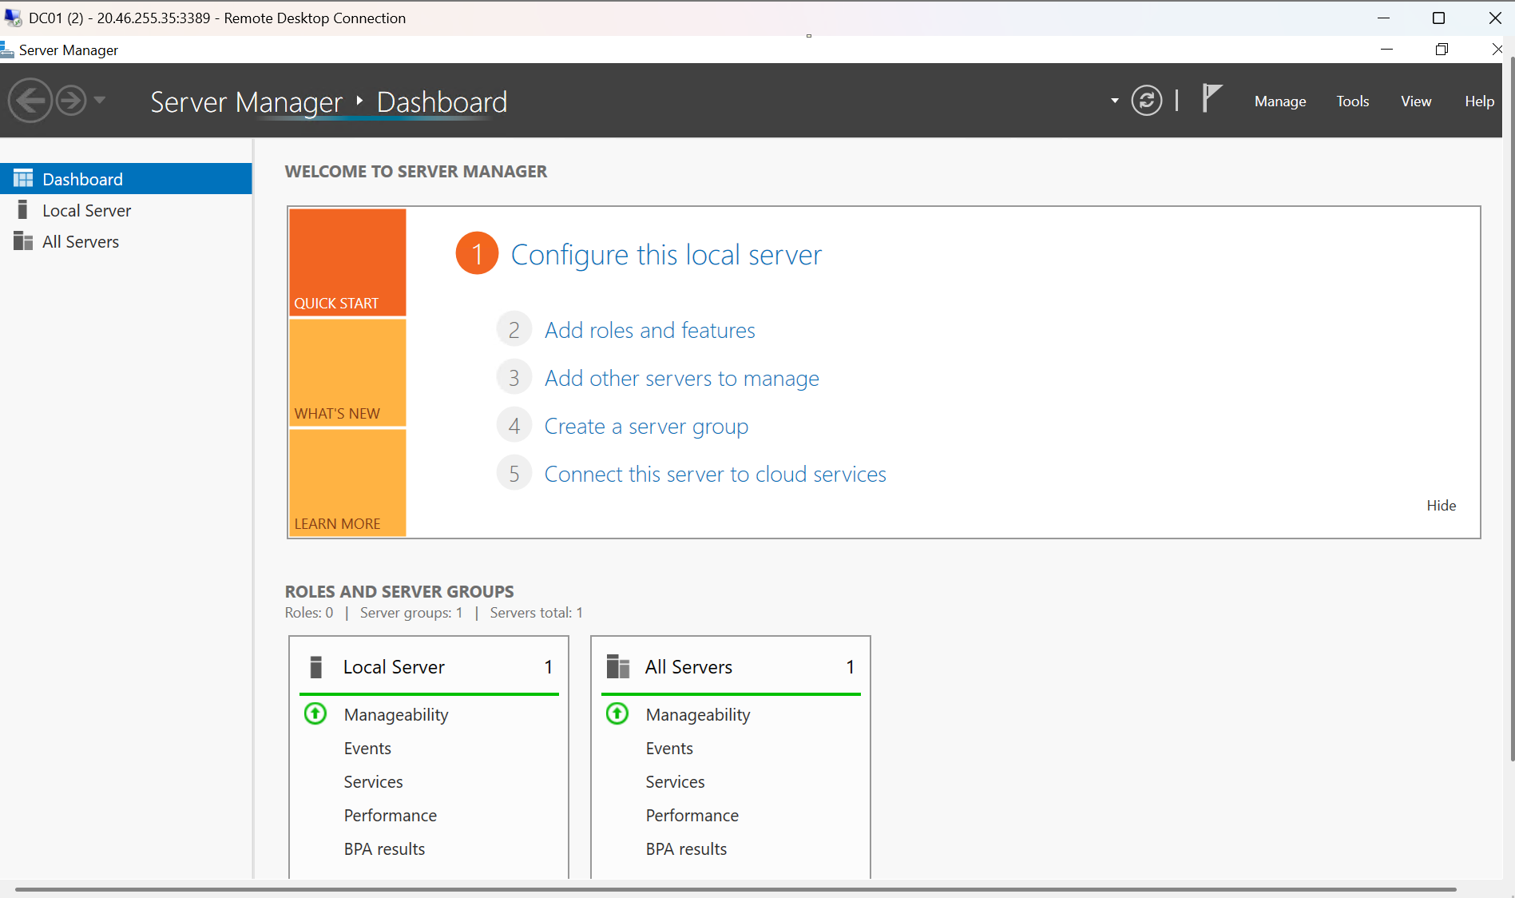

3. Select and Install the DHCP Server Role
The DHCP Server role is selected using the Add Roles and Features Wizard. Required Remote Server Administration Tools (RSAT) are included to allow local and remote management of DHCP services. Installing these tools ensures administrators can manage scopes, leases, and options without requiring direct console access.
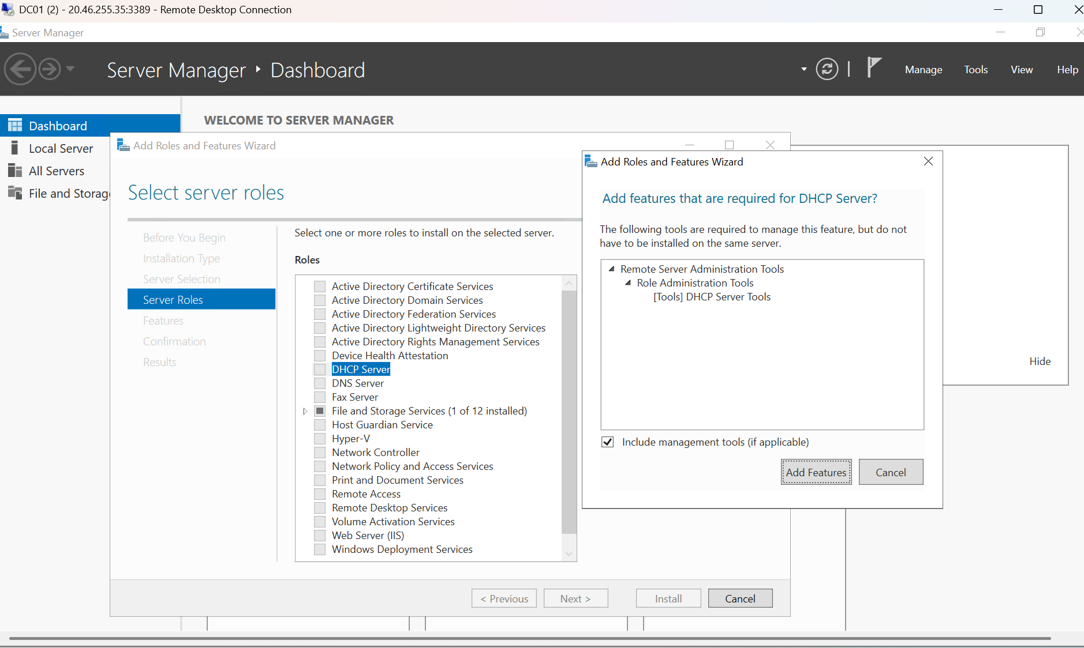

4. Validate Successful DHCP Role Installation
The installation progress screen confirms that the DHCP Server role and associated administration tools are installed successfully. Validating role installation ensures the server is capable of issuing IP leases and managing DHCP configurations before proceeding.
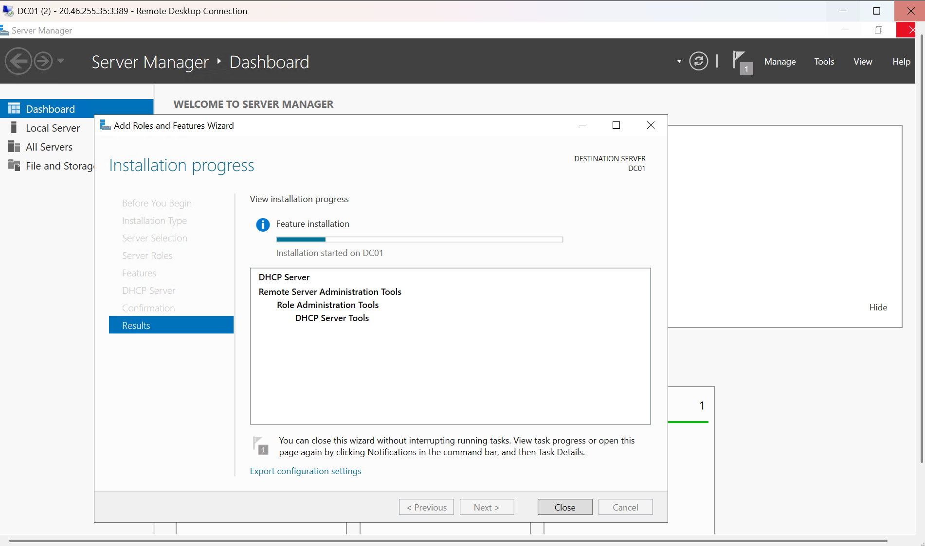

5. Create DHCP Scope and Define IP Address Pool
A new IPv4 scope is created using the New Scope Wizard. The IP address range defines the pool of addresses available for dynamic assignment. Using a /24 subnet provides clear address boundaries, simplifies troubleshooting, and reflects common enterprise subnetting practices.
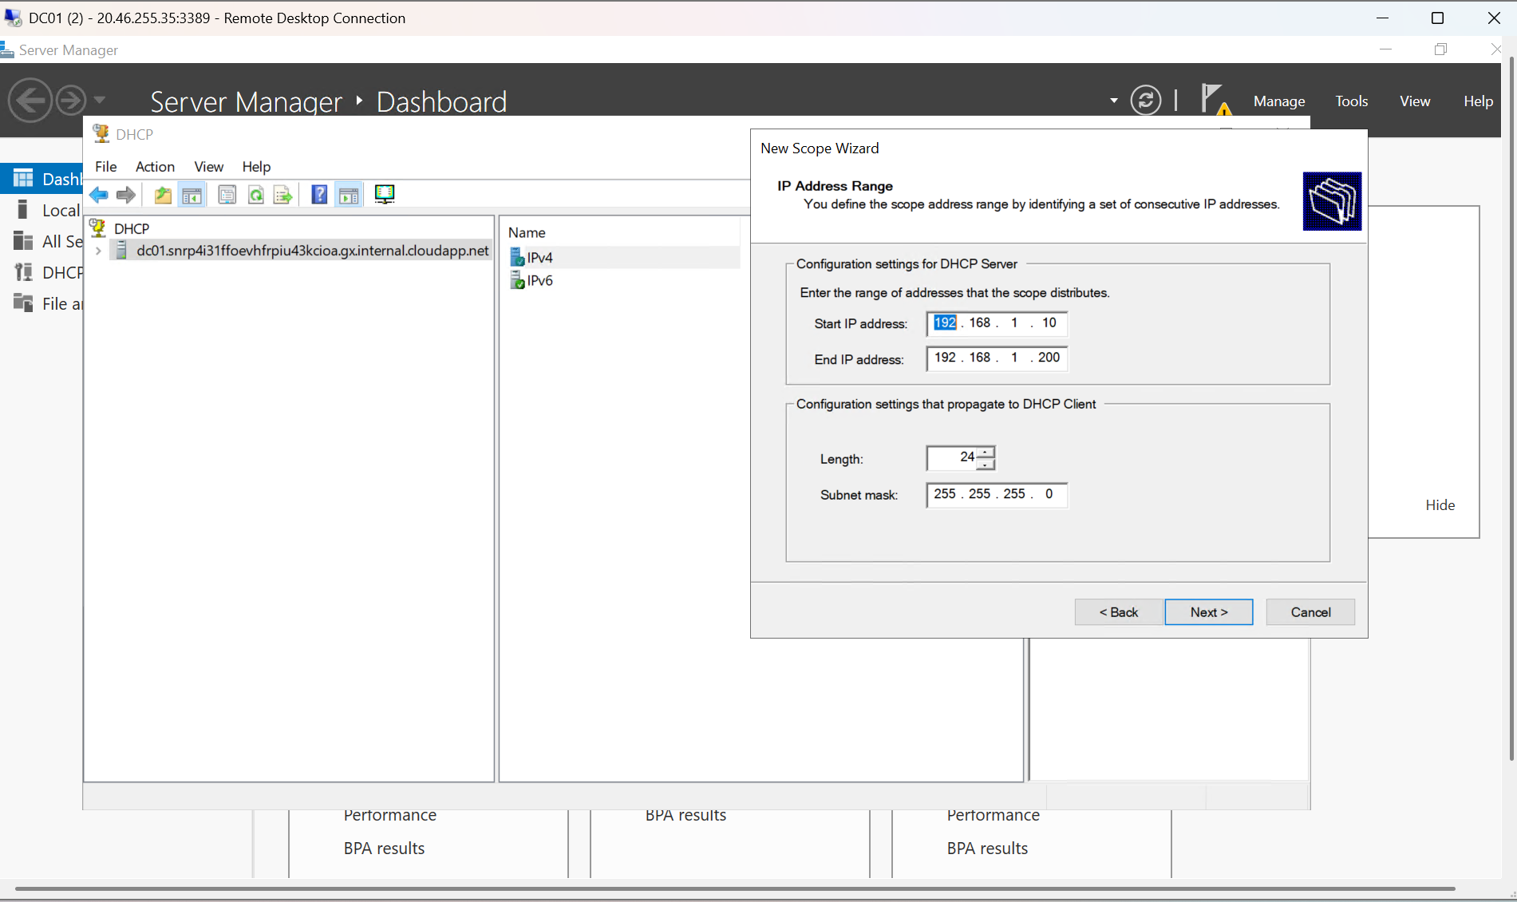

6. Configure Address Exclusions
Exclusion ranges are defined to prevent DHCP from assigning IP addresses reserved for infrastructure devices such as servers, network appliances, or statically configured hosts. This prevents IP conflicts and preserves predictable addressing for critical systems.
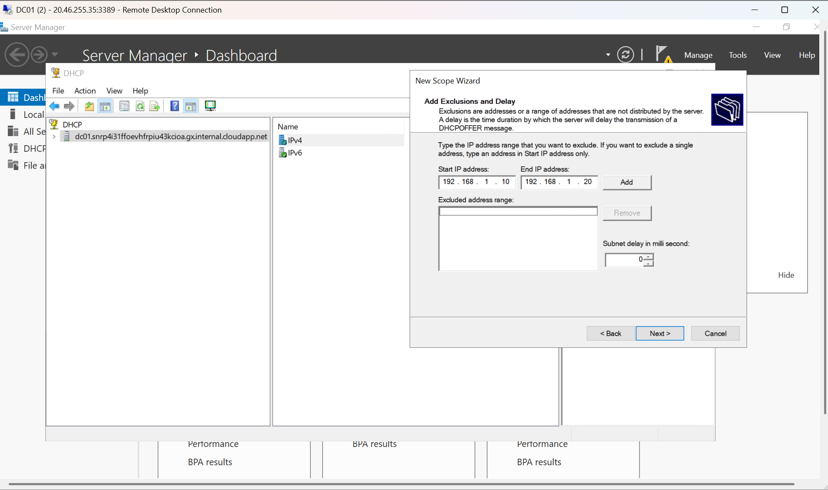

7. Set Lease Duration Based on Network Usage
Lease duration is configured to control how long a client retains an IP address. Appropriate lease timing balances address availability with network stability, ensuring efficient IP utilization while minimizing unnecessary renewals.
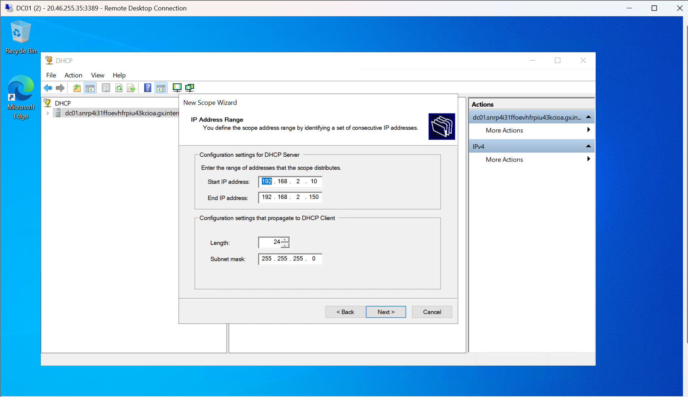

8. Adjust Lease Duration for Transient Clients
An alternate lease duration configuration demonstrates shorter lease periods typically used for guest or transient devices. Shorter leases help reclaim IP addresses quickly in high-turnover environments.
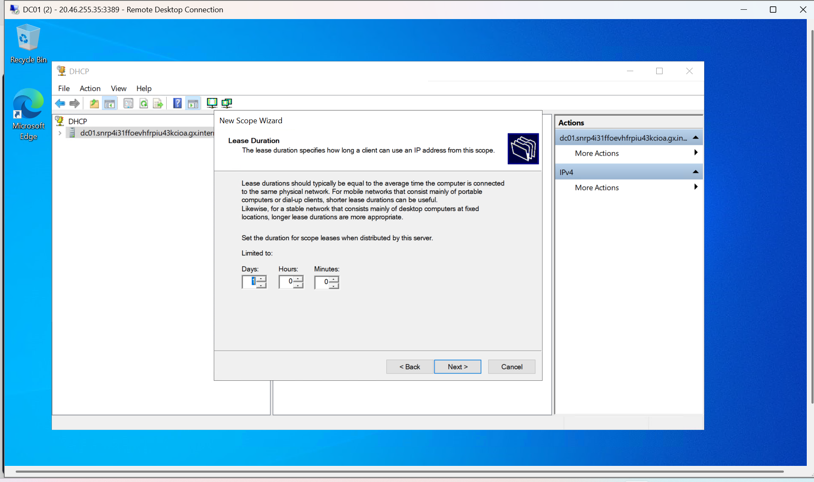

9. Configure DHCP Scope Options
Scope options are configured to provide clients with essential network settings. Option 003 (Router) specifies the default gateway, while Option 006 (DNS Servers) ensures clients can resolve domain names. Centralizing these settings through DHCP enforces consistent client configuration across the network.
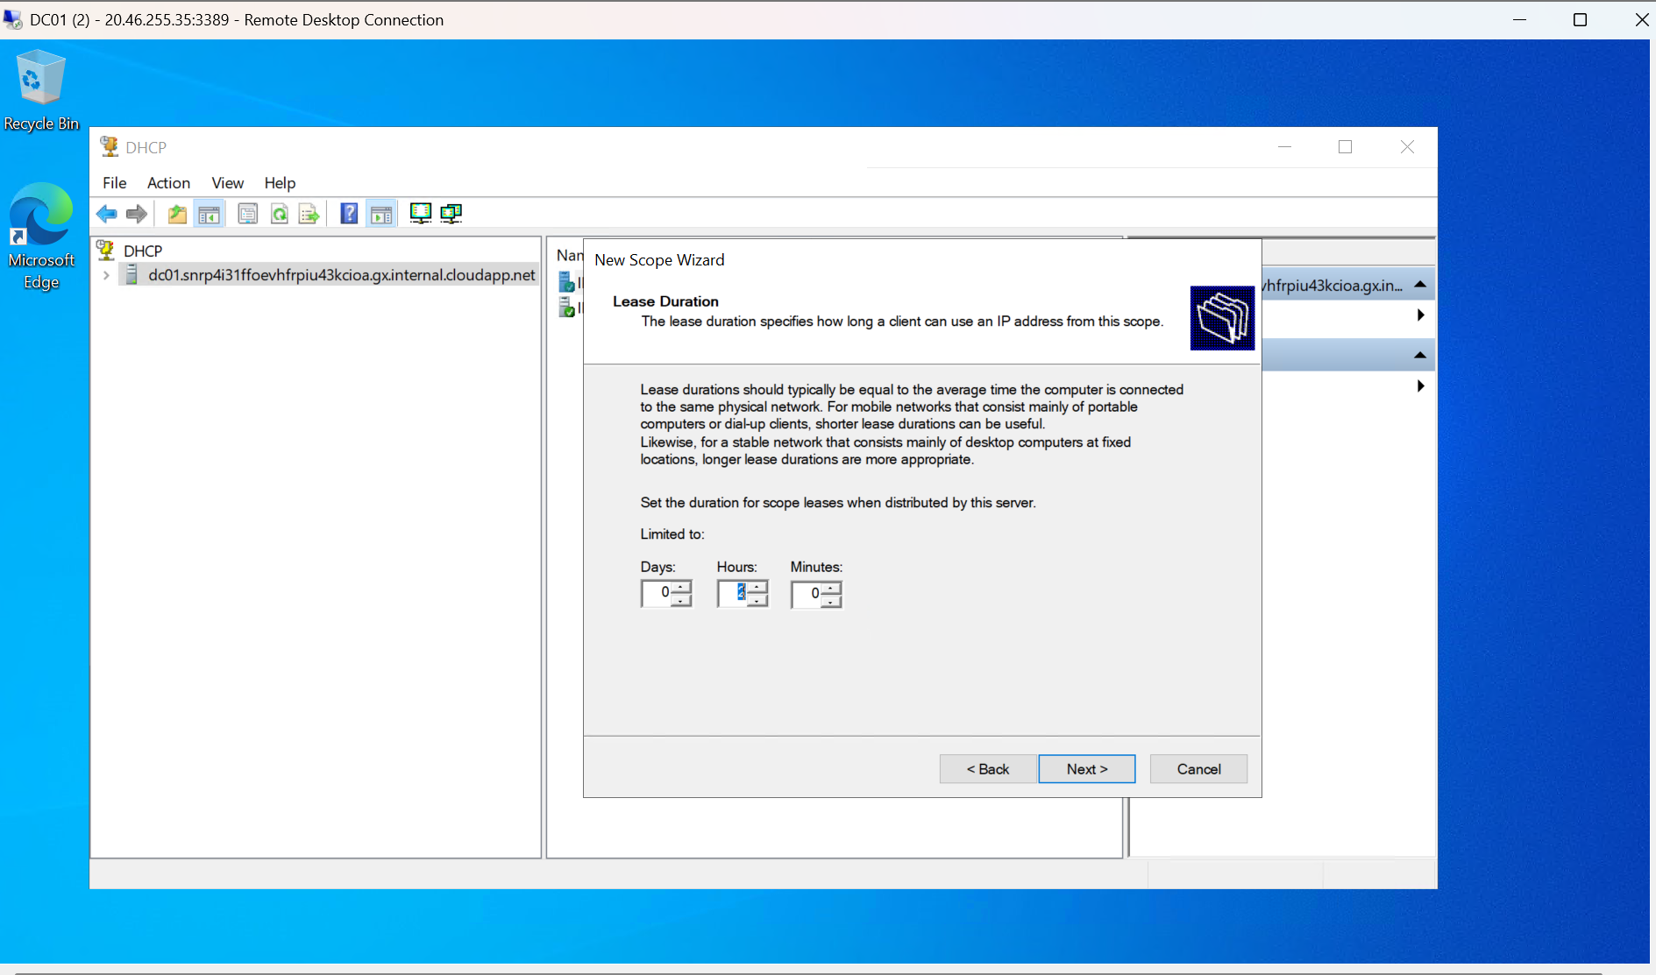

10. Create DHCP Reservations for Critical Devices
A DHCP reservation is created to assign a consistent IP address to a specific device based on its MAC address. Reservations provide the reliability of static IPs while maintaining centralized management through DHCP.
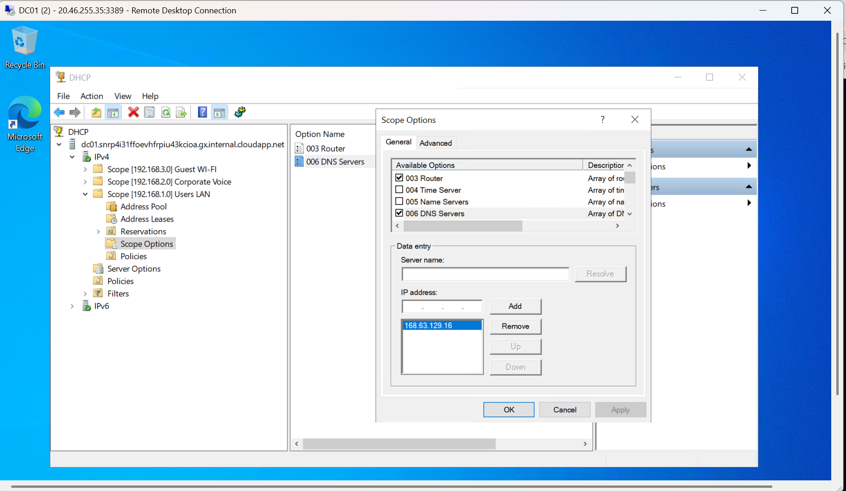

11. Review and Validate Multi-Scope Configuration
The final DHCP console view confirms multiple active scopes representing segmented network environments such as Guest Wi-Fi, Corporate Voice, and Users LAN. Scope segmentation improves security, performance, and administrative control.
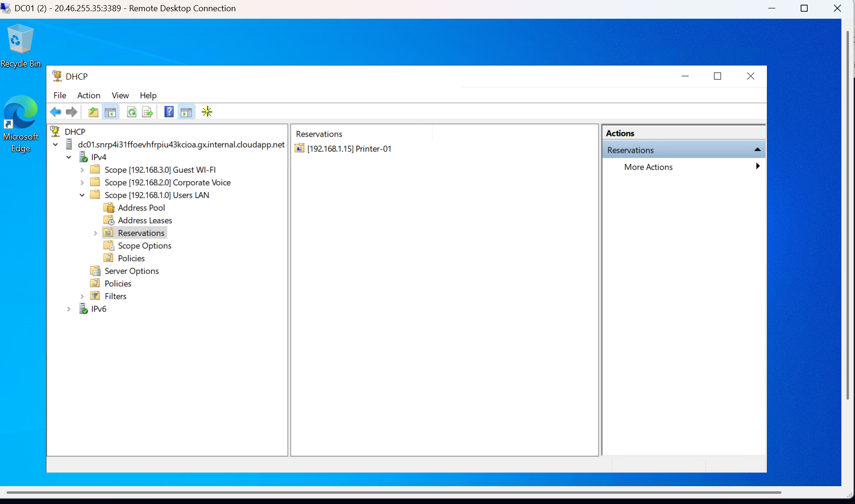

12. Outcome and Operational Validation
Upon completion, the DHCP Server was fully operational and capable of servicing multiple network segments. IP address allocation, lease management, scope options, and reservations were verified through the DHCP management console. This SOP reflects real-world enterprise DHCP deployment standards and operational best practices.

